## 

## The current service

### 

## The population that the service provides for

|  |  |  |  |  |  |
| --- | --- | --- | --- | --- | --- |
|  | **Population** | **Number of households** | **Average household size** | **Median resident age** | **Percentage of residents disabled under the Equality Act** |
| South Oxfordshire | 151,800 | 61,497 | 2.47 | 43 | 13.7% |
| Vale of White Horse | 142,100 | 57,498 | 2.47 | 41 | 14.6% |

## The cost of the joint waste and street cleansing service

The total cost of waste collection and street cleansing across the two districts is approximately £17 million, with £1 million of this spent on fuel and £750,000 on managing dry mixed recycling (green bin). The costs for disposal of residual (black bin), food and garden waste are covered by Oxfordshire County Council.

## Household waste

The following amount of waste was collected in the districts during the year April 2023 – March 2024.

|  |  |  |
| --- | --- | --- |
| **Waste type** | **South Oxfordshire** | **Vale of White Horse** |
| Green waste (tonnes) | 14,624.08 | 11,869.73 |
| Food waste (tonnes) | 6,098.54 | 5,326.88 |
| Re-use (tonnes) | 202.95 | 108.31 |
| Dry mixed recycling (tonnes) | 13,291.63 | 12,484.35 |
| Residual (tonnes) | 1,036.96 | 17,973.51 |

## Recycling rates

The two district councils have been consistently at the top of the recycling league tables for England. The figures in the table under are for the financial year 2022/23. This is based on the combined weight of all recycling streams, as a percentage of the total waste collected. Note that NI stands for National Indicator.

|  |  |  |
| --- | --- | --- |
| **Rank** | **Local Authority** | **Recycling Rate**  Percentage Household waste sent for Recycling, Reuse or Composting (Ex NI192) |
| 1 | South Oxfordshire District Council | 61.6% |
| 2 | Three Rivers District Council | 61.5% |
| 3 | Vale of White Horse District Council | 60.9% |
| 4 | St Albans City and District Council | 60.1% |
| 5 | Stratford-on-Avon District Council | 60.0% |
| 6 | East Devon District Council | 59.5% |
| 7 | Stockport MBC | 59.3% |
| 8 | Surrey Heath Borough Council | 59.3% |

The following table shows the residual waste in KG weight, as a percentage of all waste per household, for 2019/20.

East Riding of Yorkshire has been added as a comparative authority (designated in the affluent/rural category) as well as Oxford City Council, as a neighbour, who in 2019/20 were ranked 64th in the recycling league tables.

|  |  |
| --- | --- |
| **Residual household waste per household** (kg/household) (Ex NI191) | **Rank** |
| Vale of White Horse | 3 |
| South Oxfordshire | 6 |
| Oxford City | 13 |
| East Riding of Yorkshire | 59 |

The overall weight of non-recyclable material (residual waste) collected by the councils keep the two districts within the top ten.

When the overall weights of waste and recycling collected per person is considered that is where there is a marked shift in where South and Vale are positioned.

|  |  |
| --- | --- |
| **Collected household waste per person** (kg) (Ex BVPI 84a) | **Rank** |
| Vale of White Horse | 79 |
| South Oxfordshire | 146 |
| Oxford City | 6 |
| East Riding of Yorkshire | 347 |

## Waste collection arrangements for non-residential premises

The Councils will collect from the following premises, properties and facilities when requested with no charge made for collection or disposal. Waste from these premises is household waste under the Environmental Protection Act 1990 (EPA) and the Controlled Waste Regulations 1992 (CWR):

(a) Military Barracks Single Living Accommodation and Married Quarters

(b) Places of Religious Worship

The Councils will collect from the following premises when requested by the Authorities with no charge being made for disposal. The Authorities can make a charge for collection:

(a) Educational Establishments, Hospitals and Residential Homes

(b) Charities and Charity Shops

(c) Caravan and Camp Sites

(d) Prisons

## Street cleansing

The following charts summarise the types of the work of the Street Cleansing teams deal with outside of routine street cleansing.

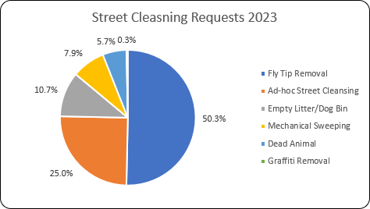

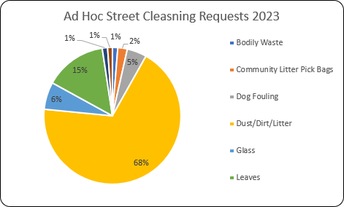

## Fly tips

The following graphs show the number of fly tip incidents reported across the districts, the number investigated, and where further action was taken.