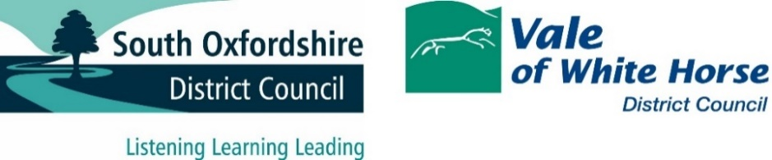

Glossary of terms
DMR – Dry Mixed Recyclate. This is glass, paper/card, plastic and metal. Dry, because it does not include food or garden waste, which is classed as organic recyclate.
Detritus – The likes of grit, silt, soil and decaying organic matter such as rotting leaves. It is often referred to in the context of street sweeping, to differentiate if from litter and the likes of plastic, glass, paper and metal items.
Residual – sometimes called General Waste. It is what is left when all the recyclate has been removed. It should make up only around 20% of everything thrown out by householders.
Twin stream recycling – this is where the DMR is separated, for instance the glass or the paper and card are not collected in the same container.
Multi-stream recycling- this is where as many different dry mixed recyclable materials are collected separately at the kerbside in several or more containers.
Kerbside sort – The way the collection system that utilises multi-stream recycling operates, with the RCV having multiple separate containers for each separate recycling material. It is labour intensive, but cuts out the need for a MRF and sustains higher value from the recyclate.
MRF - Material Recovery Facility. Pronounced Merf, stands for Material Recovery Facility. It is where the dry mixed recycling gets sent to be separated out into the different material streams (plastic, glass, paper/card, metals)
Processing site – this will be where any source-separated material will go to. For instance, the textiles collected separately with recycling will go direct to a textile merchant. It is where the mixed recycling goes after if has been sorted at the MRF. These locations can be overseas.
RCV – Refuse Collection Vehicle. That will be Dustcart or Binwagon to most people.
HWRC - Household Waste Recycling Centre. The council tip or the dump to most people.
TS - Transfer Station. where collected waste gets dropped from the back of an RCV before being loaded with a JCB-type vehicle into a large lorry for the onward journey to a MRF, processing or disposal site.
Depot – where the waste vehicles and core operational staff are located
EA – Environment Act. Also, can be used to refer to the Environment Agency. The Environment Act is the flagship central government policy designed to create a step-change in how waste is produced, collected, and processed. It has been the subject to successive delays.
CE - Circular Economy. The linear model is to extract natural resources, manufacture something, use it then dispose of it. The circular economy avoids using virgin material, makes items repairable or built to last and when finally of no more use, recycles or re-purposes items into other products.
Waste Hierarchy – This is a triangle with disposal at the bottom (the worst outcome for waste) followed by recovery (such as being burnt to make electricity) then recycling (which is not the most desirable outcome) then to the top tier of re-use, repair, refill. At the top of the triangle is reduce. To simply not make so much waste in the first place.
Windrow – this is how garden waste gets turned into compost/soil improver. It is simply piling up the garden waste into long rows that are regularly turned to help them rot-down.
Anaerobic digestor – this is where the food waste goes to. It is a fast-composting arrangement where the food is deprived of air, rots very quickly and releases its methane. The methane is captured and used to power turbines for electricity, or is cleaned and used as mains gas.
Energy From Waste – this can also be called energy recovery. It is where non-recyclable waste is burnt in an incinerator with the heat used to drive turbines that generate electricity for the national grid.
WRAP – Waste Resource Action Programme. National charity with government support that promotes various resources to increase sustainability and encourage the circular economy within the waste sector
LARAC – Local Authority Recycling Advisory Committee. National subscription body championing recycling and related waste-related issues from a local authority perspective.
DEFRA- Department of Food and Rural Affairs. It is the government department overseeing waste and environmental activity.

