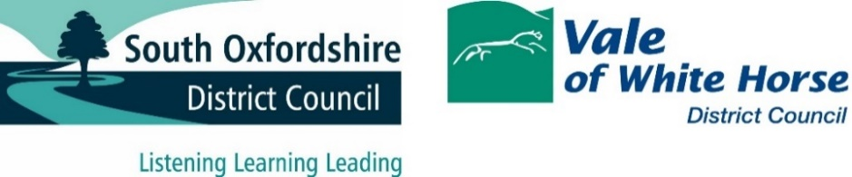

Government policy and legislation changes and their impacts upon the councils

Extended Producer Responsibility (EPR)
South Oxfordshire and Vale of White Horse councils can expect, from 2025 onwards to operate within a new funding framework, using payments from packaging producers in the form of Extended Producer Responsibility (EPR).
The proposals at the time of writing this strategy were that producers would initially be asked in 2023/24 to monitor the packaging they produced ready to be reporting compliant.
In 2024/25 local authorities would be obliged to offer additional information to the body overseeing EPR and packaging producers would be expected to commence payments. This would initially be to develop a fund used to support those councils needing new infrastructure, vehicles, or other such requirements, so as to comply with measures within the Environment Act.
Central government have signalled that this money will be used for those needing to launch a weekly food waste collection service and/or to be able to collect the full set of core Dry Mixed Recyclable materials. There have been no indication that it will be available for other changes. This makes it appear unlikely that South Oxfordshire or Vale of White Horse Councils will be able to apply for funds available from the EPR scheme administrator.
By 2025/26 South Oxfordshire and Vale of White Horse Councils will receive a set annual grant (based on the ‘family’ of authorities it sits within). In addition, local authorities can claim a yet unknown additional amount based on the efficiency of the packaging collected systems used. This is to incentivise higher performing authorities able to capture and retain key packaging as a resource.

Deposit Return Scheme (DRS)
This will see plastic bottles holding liquids, as well as metal drink tins/cans, be subject to a redeemable deposit from the place where they were purchased. For plastic bottles it is proposed that it includes containers able to hold up to three litres of liquid.
As it is currently proposed that the DRS does not include glass, then by weight the modelling indicates that less than ten percent of the overall Dry Mixed Recycling will be lost from kerbside collections when it is introduced on October 1, 2025.
However, by volume, i.e. the space that plastic bottles (including the large plastic milk bottles) take up in the recycling bin, is far bigger than the weight of the items alone would indicate. The working assumption is that between a fifth and a quarter of the space in the Dry Mixed Recycling bin could be freed up by drink containers (except glass) being returned directly to shops, rather than placed within kerbside-collected bins.
The implications of this are that the councils, were they not to change the size or frequency of their Green Bin collections, would be emptying bins that are less likely to ever get full.

Simpler Recycling
There are few impacts directly from these proposals on the councils due to the fact that many of these requirements have already been implemented. The main impact will be the need to collect plastic film, as it will be included within the core material set local authorities must collect from 2027. The councils will need to determine how it is collected, and how it is processed. As the set of materials that local authorities collect will be standardised, all Material Recovery Facilities (MRFs) will be required to collect the full co-mingled material set by 2027. The expectation is that they will all be able to comply with this requirement.
Collection frequency looks unlikely to be a statutory requirement, with a cap on frequency at two weekly intervals for DMR and non-recyclable waste, as guidance only. This has yet to be confirmed.

Summary of national government changes
Due to being placed at the top of the recycling league tables, South Oxfordshire and Vale of White Horse are in a strong position to gain any incentive payments offered through the Extended Producer Responsibility process.
With climate concerns the key driver, then efficiency in capturing as many resources as possible is already central to all future service activity.
The Deposit Return Scheme presents an opportunity to reconfigure kerbside collection, revisiting containers, bespoke material collection (such as textiles and small electricals) and consider any knock-on effect to round logistics through a reduced volume of recycling available for collection.
A DRS will also mean a drop in income from the sale of recyclate, as the higher value recyclate (plastic and metal drink containers) become far less common in kerbside recycling bins. The government predicting that by the third year of operation, over 90% of ‘in-scope’ DRS items will go directly back to retailers.
For Simpler Recycling, that is the requirement for all authorities to collect the same set of recyclable materials, based on the current proposals, the effects for South Oxfordshire and Vale of White Horse, will be minimal.

