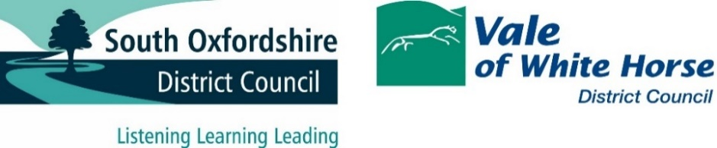

Waste and Street Cleansing Strategy Council Members Consultation

As part of work to develop a joint Waste and Street Cleansing Strategy for South Oxfordshire and Vale of White Horse District Councils, two consultation events were held with elected members of the councils to gather views in order to help shape the waste collection and street cleansing services in the future.

The first event was an in-person session held at Didcot Civic Hall on 10 October 2023 and the second event was held online on 19 October 2023. A total of 43 elected members attended the sessions with 41 registering their views on ten strategic questions via the Mentimeter voting system.

**Attendees**

In-person event, 10 October

|  |  |
| --- | --- |
| **South Oxfordshire District Council** | **Vale of White Horse District Council** |
| Cllr Ken Arlett  Cllr Pieter-Paul Barker  Cllr Robin Bennett  Cllr Sam Casey-Rerhaye  Cllr Peter Dragonetti  Cllr Maggie Filipova-Rivers  Cllr Ali Gordon-Creed  Cllr Andrea Powell  Cllr Leigh Rawlins  Cllr David Rouane  Cllr Anne-Marie Simpson  Cllr Tony Worgan | Cllr Ron Batstone  Cllr Sue Caul  Cllr Robert Clegg  Cllr Mark Coleman  Cllr Andrew Crawford  Cllr Eric De La Harpe  Cllr Debra Dewhurst  Cllr Lucy Edwards  Cllr Neil Fawcett  Cllr Andy Foulsham  Cllr Hayleigh Gascoigne  Cllr Jenny Hannaby  Cllr Sarah James  Cllr Jill Rayner  Cllr Judy Roberts  Cllr Bethia Thomas  Cllr Max Thompson |

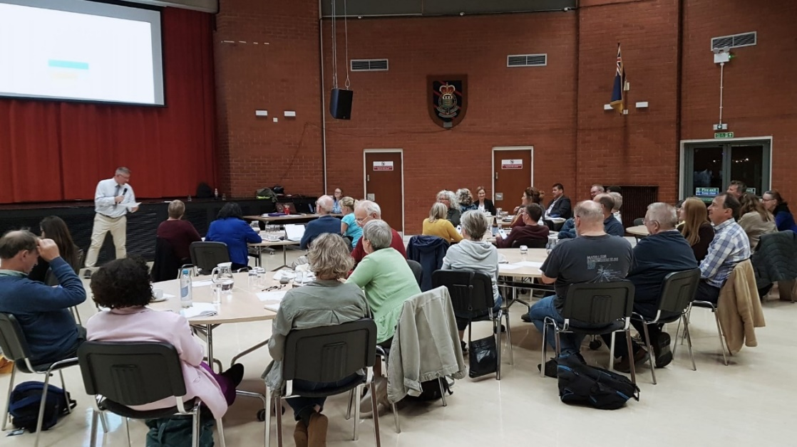

Online event, 19 October

|  |  |
| --- | --- |
| **South Oxfordshire District Council** | **Vale of White Horse District Council** |
| Cllr James Barlow  Cllr Mike Giles  Cllr Kellie Hinton  Cllr Ian Snowdon  Cllr Andrew Tinsley  Cllr David Turner | Cllr Paul Barrow  Cllr Debby Hallett  Cllr Scott Houghton  Cllr Diana Lugova  Cllr Patrick O'Leary  Cllr Viral Patel  Cllr Helen Pighills  Cllr Val Shaw  Cllr Emily Smith |

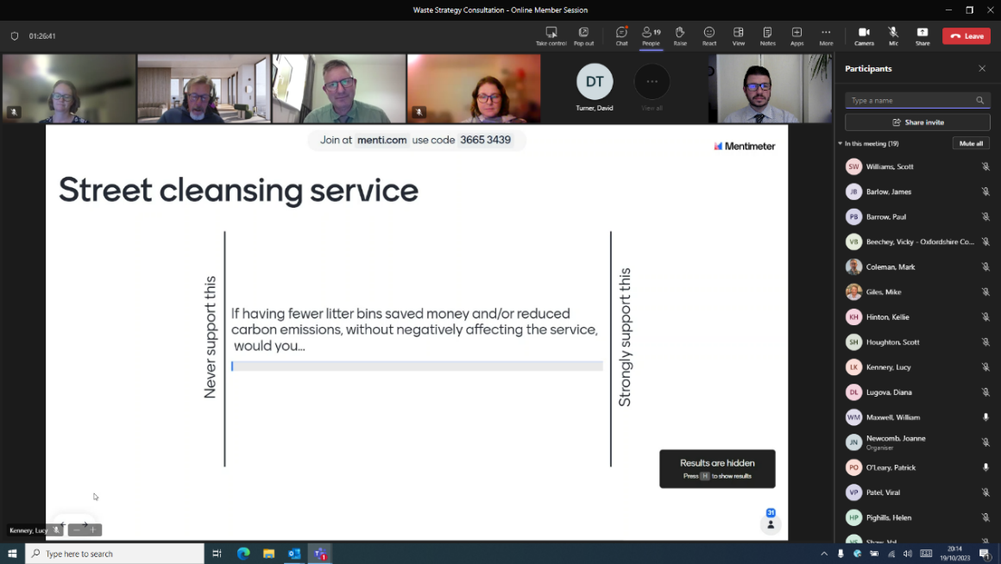

**Summary of responses to ten strategic questions**

Climate, Cost and Convenience

Members were asked to rank the importance of climate, cost and convenience when considering the waste and street cleansing service in the future. 67% think the biggest priority should be climate, followed by convenience, then cost.

Household waste and recycling service

Members were asked three questions relating to the potential for a waste and recycling service which asks residents to do more. Responses were mixed with 52% supportive, 19% neutral and 29% unsupportive.

When responding to more specific questions about residents taking responsibility for storage and sorting of their waste and recycling, 60% agreed that residents should be asked to do more if it leads to better environmental outcomes. Only 36% agree that residents should be asked to do more if it leads to financial benefits.

Greenhouse gas emissions

A majority of council members (64%) believe it is important that any future waste and street cleansing strategy is designed to tackle scope two and three greenhouse gas emissions as well as scope one.

|  |  |  |
| --- | --- | --- |
| **Scope 1**  Emissions released as a direct result of council activities e.g. fuel in council owned vehicles | **Scope 2**  Emissions released as a result of consumption of an energy commodity e.g. purchased electricity for office lighting | **Scope 3**  Emissions released indirectly, upstream or downstream, of council activities e.g. purchased goods and services, employee commuting, waste disposal |

Street cleansing

A majority of members (57%) were supportive of asking the public to take more responsibility for managing litter and their local environment but were generally not supportive of having fewer litter bins, even if it saved money and/or reduced carbon without negatively affecting the service.

Half of members (50%) believe streets should only be cleaned as and when needed, 29% believe a regular and visible service is preferable, and 21% were neutral or would support a combined approach.

Control over operation of the services

Members were asked if having more direct control over the services in the future is important. 76% believe it’s important for the street cleansing service, and 68% believe it’s important for the household waste collection service.

**Responses by question**

Question 1: What do you think should be the biggest priority for the waste and street cleansing service in the future?

Rank the options from 1st to 3rd: Climate, Cost, Convenience

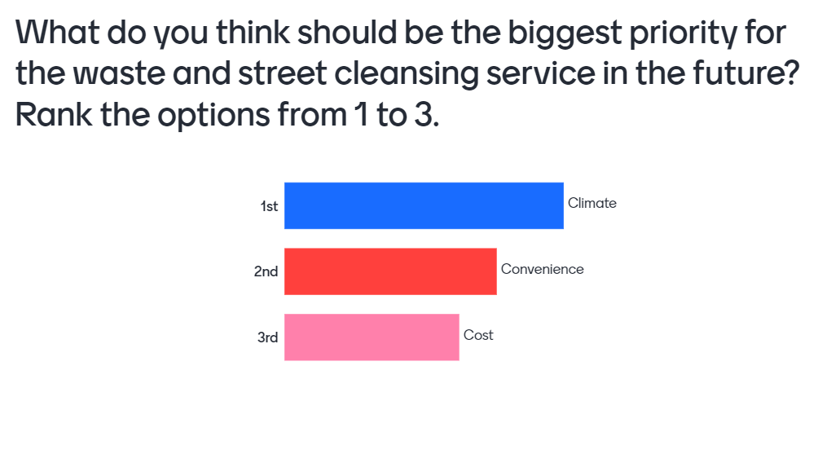

Question 2: If the waste and recycling service changed, resulting in services that needed your residents to do more, would you be…

Scale from Unsupportive (1) to Supportive (5)

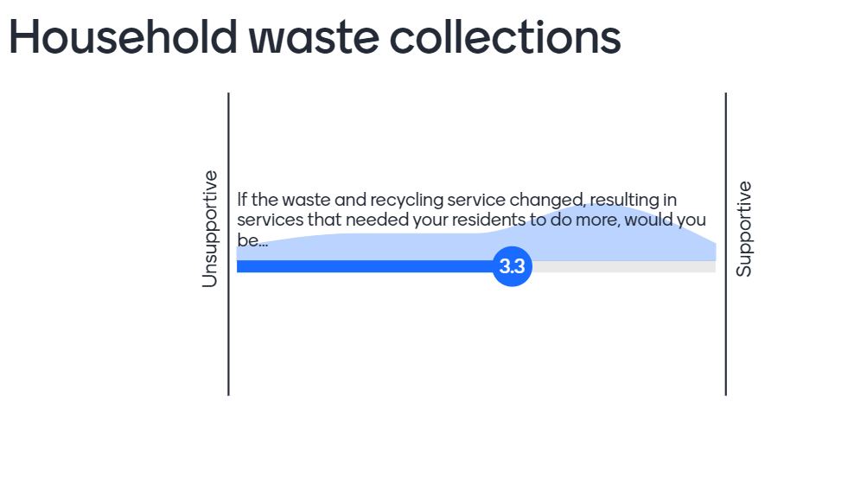

Question 3: Residents should take more responsibility for storage and sorting of their waste and recycling, if it leads to better environmental outcomes.

Scale from Strongly disagree (1) to Strongly agree (5)

Chart showing how far people agree to Residents should take more responsibility for storage and sorting of their waste and recycling, if it leads to better environmental outcomes.
Scale from Strongly disagree (1) to Strongly agree (5)


Question 4: Residents should take more responsibility for the storage and sorting of their waste and recycling if it delivers financial benefits.

Scale from Strongly disagree (1) to Strongly agree (5)

Question 5: The councils are directly responsible for GHG (Greenhouse Gas) scope one emissions. Do you think any future waste system should be designed to tackle scope two and three emissions?

Scale from No, it's not important (1) to Yes, it's important (5)

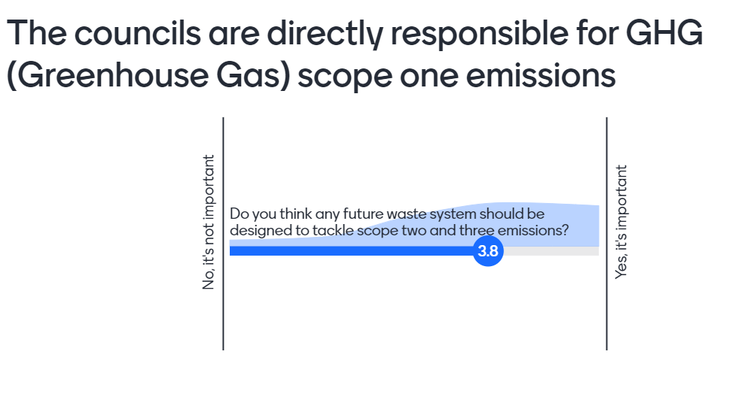

Question 6: If the public were asked to take more responsibility for managing litter and their local environment, would you be…

Scale from Unsupportive (1) to Supportive (5)

If the public were asked to take more responsibility for managing litter and their local environment, would you be… 
Scale from Unsupportive (1) to Supportive (5)
Diagram shows support

Question 7: If having fewer litter bins saved money and/or reduced carbon emissions, without negatively affecting the service, would you...

Scale from Never support this (1) to Strongly support this (5)

If having fewer litter bins saved money and/or reduced carbon emissions, without negatively affecting the service, would you... 
Scale from Never support this (1) to Strongly support this (5)
Diagram shows little support

Question 8: Which is more important: Street cleansing services which are regular and visible, or streets which are cleaned as and when required?

Scale from Regular and visible (1) to Cleaned as and when needed (5)

Which is more important: Street cleansing services which are regular and visible, or streets which are cleaned as and when required? 
Scale from Regular and visible (1) to Cleaned as and when needed (5)
Diagram shows more support for cleaned when needed

Question 9: In the future, how important is it that the councils have more direct control over the operation of the Street Cleansing service?

Scale from No, it's not important (0) to Yes, it’s important (10)

In the future, how important is it that the councils have more direct control over the operation of the Street Cleansing service? 
Scale from No, it's not important (0) to Yes, it’s important (10)
Diagram shows - people agree important

Question 10: In the future, how important is it that the councils have more direct control over the operation of the Household Waste Collection service?

Scale from No, it's not important (0) to Yes, it’s important (10)