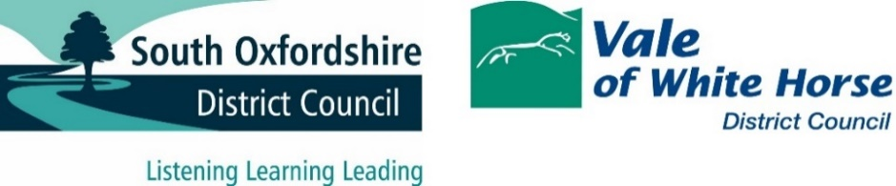

The commercial provision of waste and street cleansing services: A view on the state of play of the commercial part of the industry

At the turn of the century, around the time that Private Finance Initiatives (PFI) were, both nationally and with some local authorities, a favoured option for large infrastructure projects, there was considered to be significant opportunity, and investment within the waste industry.
Some local authorities began to move their residual waste away from landfill as a disposal option, and towards alternatives such as energy recovery from incineration
In addition, at the same time the industry was able to secure good value from the end destination markets for recyclable materials. As recyclable materials can only be reprocessed to be used as goods where there is a market to do, this was particularly in high manufacturing economies such as China.
Around 2010 a number of these factors began to change.
Regarding residual waste, several large-scale Mechanical and Biological Treatment (MBT) plants were established to extract recycling and compostable material from general waste. There was also the end of the Landfill Allowance Trading Scheme (LATS). This meant that the disposal choices were also affected as the Landfill Tax escalator began to drive disposal towards energy recovery incineration as the preferred treatment choice for residual waste.
A combination of the technical challenges posed by MBT, and the rise of energy recovery incineration, saw several leading waste companies pivot investment toward their residual disposal operations.
Moving forward to the late 2010s, China, along with some other international purchasers of recyclate, signalled that they would no longer be accepting recyclable materials from the UK. The quality of the recyclate that the UK was supplying was considered as unacceptable and these manufacturing economies had developed their own recycling infrastructure to better capture material internally. This saw the price for a number of recyclables, notably paper and card (fibre) fall dramatically.
Waste companies have fared better in processing and disposal, often posting healthy profits in these areas. As already mentioned, the Energy From Waste sector is buoyant, in particular after a 2014 report, revisited in 2017, entitled ‘mind the gap’. This report by the waste company Suez underlined the opportunities for expansion in the Energy From Waste market. This, coupled with the (steadier) growth of Anaerobic Digestion, has helped sustain a profit margin for larger players in the waste market. With both food and incineration generating electricity, the high energy prices from 2022 onwards have also contributed to high industry profits in this area.
For incineration, the inclusion of Energy From Waste plants into the Emissions Trading Scheme from 2026 to 2028, may cap profits in this area.
The final element effecting the industry has been the delays to proposed changes stemming from the Environment Act 2021. The current proposals (see earlier in this section under ‘Simper Recycling’) still have areas of uncertainty within them, as well as uncertainty over if they may survive a new government that may follow from 2024 on.
The processing and resale of Dry Mixed Recycling is likely to be volatile and largely depressed as a market, with uncertainties of the effect of the Deposit Return Scheme from 2025 on and its effect on Kerbside collected material values.
From the perspective of future industry interest, based on what is known, Energy From Waste and Anaerobic Digestion are likely to remain buoyant areas.
However household waste collection, a combination of the pandemic, and then high inflation in 2022 and 2023, has seen some waste companies suffer financial losses, particularly within their waste collection arms.
Staff and fuel costs remain high, whilst income secured from recyclable material, at the point this strategy was written, remain depressed and volatile.
Taken as a whole, the uncertainty caused by the delay in details from The Environment Act 2021 has reduced industry confidence, delayed investment and made overcoming the stagnating recycling figures tougher.
There remain industry players within the Waste Collection arena, although for a service that is staff and fuel cost heavy, margins are thin and bid teams selective.
The location of facilities is also a factor. The sorting facilities are not ideal and with a combination of distance and high levels of contamination and material rejection, this is one area where improvements can be made.

